Task 2: Inline, Internal, and External CSS
Explain the differences between inline, internal, and external CSS. Create an HTML page that demonstrates all three methods. Include examples for each type, and explain the advantages and disadvantages of using each method.
Show drafts

Inline, Internal, and External CSS
CSS (Cascading Style Sheets) can be applied to HTML documents in three primary ways: inline, internal, and external. Each method has its own advantages and disadvantages depending on the specific use case.

Inline CSS
- Definition: Styles are applied directly within an HTML element using the style attribute.
- Example:
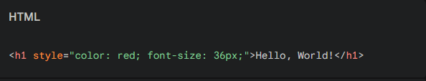
- Advantages:
  - Provides quick and easy styling for specific elements.
  - Useful for small-scale changes or temporary styles.
- Disadvantages:
  - Poor maintainability: Styles are scattered throughout the HTML document.
  - Difficult to reuse styles for multiple elements.
  - Not suitable for large-scale projects.

Internal CSS
- Definition: Styles are defined within the <head> section of an HTML document using a <style> tag.
- Example:
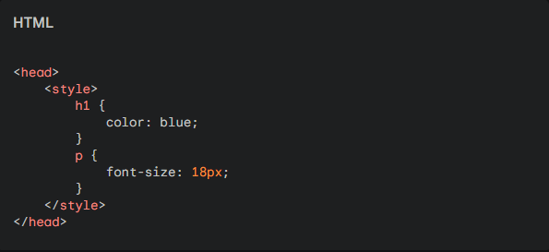
- Advantages:
  - Better organization than inline CSS.
  - Easier to reuse styles for multiple elements within the same document.
  - Suitable for smaller projects.
- Disadvantages:
  - Styles are specific to the individual HTML document.
  - Not ideal for large-scale projects or sharing styles across multiple pages.

External CSS
- Definition: Styles are defined in a separate .css file and linked to the HTML document using the <link> tag.
- Example:
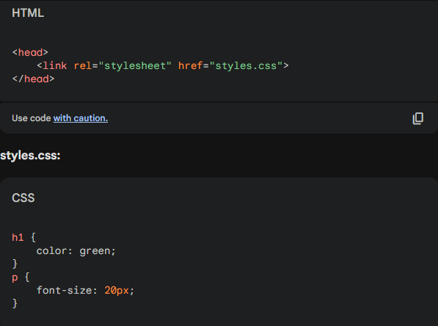
- Advantages:
  - Improved separation of concerns between content and presentation.
  - Easier to maintain and reuse styles across multiple HTML documents.
  - Ideal for large-scale projects and collaborative development.
- Disadvantages:
  - Requires additional HTTP requests to load the CSS file.
  - Can slightly impact initial page load performance.

Demonstrating All Three Methods
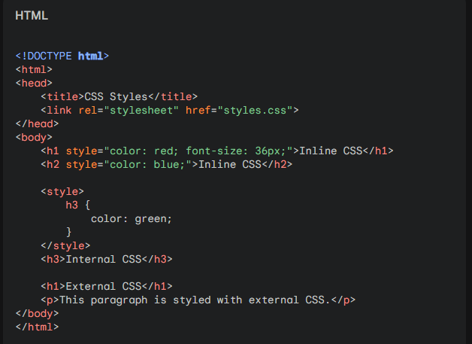
This HTML document demonstrates all three methods of applying CSS. The first two headings use inline CSS, the third heading uses internal CSS, and the remaining elements use external CSS from the styles.css file.

